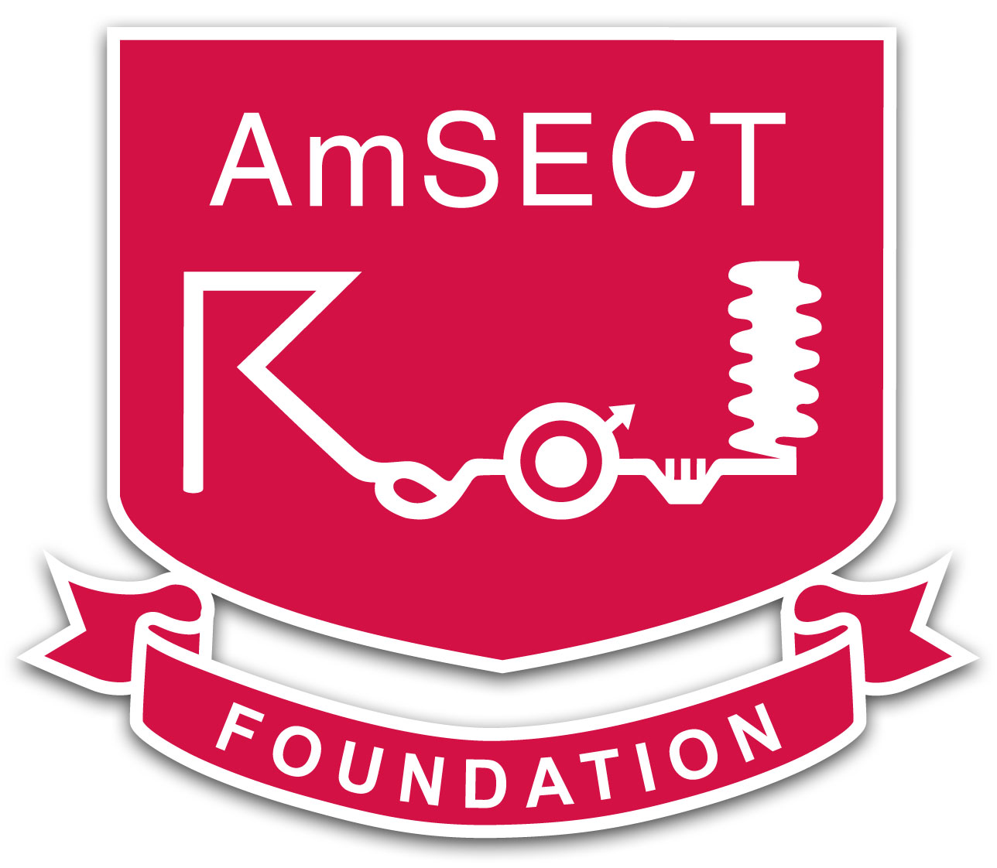 | 

<date>

<charity name>
<mailing address>

Dear <representative>,

The American Society of ExtraCorporeal Technology (AmSECT) strongly supports student development. In alignment with our mission statement, one of our goals is to assist in the growth of well-rounded professionals who can complement clinical skills with life experience and personal insight. Exposure to mission work is an excellent opportunity to enhance that perspective.

Perfusion Without Borders, in conjunction with the AmSECT Foundation, offers one annual student scholarship of up to $3000, to be used for personal travel expenses on a selected cardiac mission. Our student scholarship winners have found their experiences to be significant events in the development of their professional careers.

Once a student is accepted for a mission trip with an organization such as yours, they are then eligible to apply for AmSECT’s Perfusion Without Borders student scholarship. PWOB’s application deadline is September 1st, and the recipient is announced by October 1st. You may be receiving inquiries from multiple students who are applying for this scholarship as an opportunity to pursue an event which they might not otherwise be able to afford. Should a student be selected by you to attend a mission, but subsequently not be granted the scholarship, it is possible that their limited financial status may prevent them from attending and they may be forced to withdraw. As such, we would ask that any student you select who is also applying for the PWOB scholarship be offered selection on a provisional basis and provided the opportunity to withdraw from their commitment, should they need to.

You have our greatest respect and admiration for all the good work that you do, and we appreciate your flexibility in accommodating the scholarship procedure. We are hopeful that having knowledge of this time frame will assist you in planning. Please contact us at the email addresses below with questions or concerns.

Sincerely,
Perfusion Without Borders Committee

Scott Snider, IMC Chairman, CardioStart International, william.snider@duke.edu
Brian C. Forsberg, Chief Perfusionist and Co-Founder, The William Novick Global Cardiac Alliance, brian.forsberg@cardiac-alliance.org
Molly Oldeen, volunteer, Open Hearts International
Jordan Voss, volunteer, International Children’s Heart Foundation and Gift of Life International
Whitt Behr, volunteer, Cardiostart International

National Headquarters | 330 N. Wabash Ave. Suite 2000 | Chicago, IL 60611 | (312) 321-5156

